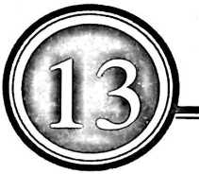

INFORMATION SEEKING BEHAVIOUR AND
USE OF INFORMATION RESOURCES, BY
BINGHAM UNIVERSITY HUMANITIES, SOCIAL
AND MANAGEMENT SCIENCES
UNDERGRADUATE STUDENT.
Opeyemi Oluwabumni Oyinloye*
Tabawa Yusuf Dangwaran**
and
Helen Solomon Kantiok***
♦Opeyemi Oluwabunmi Oyinloye is curremly an Assistant Librarian and Head, Reference section of Bingham University Library, Kara -
Nasarawa State She, holds a Bachelor’s Degree in Library Science from Delta State University, Nigeria. Her areas of research interest include:
Research and information management. E-mail: oyinbunmi007@gmail.com Phone No. +2347030679036
*♦ Tabawa Yusuf Dangwaran is currently an Assistant Librarian and heads Pre-clinical library, Bingham University Kara. Nasarawa State.
She holds a Bachelor’s Degree in Library Science from University of Maiduguri, Borno State., Her areas of research interest include:
reference and user education. E-mail: dangwarantabawa@yahoo.com Phone No. +2348069791023
♦♦♦ Helen Solomon Kantiok is currently working at Bingham University Library Readers’ service division. She holds a Bachelor’s Degree in
Library and information science From Ahmadu Bello University, Zaria.. Her areas of research interest include: reference and research
information services. E-mail: just4him83@yahoo.com Phone No: 2348036020574,
Abstract
This study investigated the information seeking behavior and use of information by Bingham
University humanities, social and management science students. A structured questionnaire was
used for data gathering in the University. The questionnaire data was analyzed using frequency, bar
chart, pie chart and percentage for easy interpretation.
The research findings show that the respondents use goggle, print textbooks, library materials and
social media as major research engines. Non availability of current information resources,
inaccessibility of information resources, unavailability of internet access, were found as barriers to
information seeking behaviour of the respondents. The following were recommended in line with
the findings of the study:
Provision of information materials to meet the information needs of students. Creation of awareness
programme that will enlighten the students in getting adequate information needed in the library
such as asking a librarian, the use of Online public access(OPAC) and E-granary to get the adequate
information they need, The library should acquire relevant books that will meet the information
needs of users, The librarians and the other officers of the library should be trained properly for
them to be able to meet the information needs of the students.
Key Words: Information, Seeking, Behavior, Resources. Undergraduate, Students.

Introduction
Information is an important factor in any
library because they are needed by users.
Every library user needs information of
increasing variety and diversity of levels,
frequencies, volumes and with ease.
Therefore, information need stems from a
vague awareness of something missing and
as culminating in locating information that
contributes to understanding and meaning
Library patrons seek information because
they need information resources to survive in
all sectors of life (Ajiboye and Telia, 2007,
Fiankor and Adams, 2004, Fatima and
Ahmad (2008)).
The library user makes use of a library
for a variety of reasons. Some use a Library
for specific reasons, preparation for exams
and professional development. Aina (2004)
says it is known however that the different
information user’s categories have different
information needs which a library must
strive to meet. Information need is often
understood in information science as
evolving from a vague awareness of
something missing and as culminating in
locating information that contributes to
understanding and meaning. The present era
is called the “Information era.” Information
has become the most important element for
progress in society. To thrive in this modern
era, one needs a variety of information, no
matter how well versed one is in a field or
profession. Psacharopoulous (1982)
discusses the necessity of information in the
present age. We can reorganize the
educational system and redefine scientific
research only with the help of information.
According to Nnadozie et’al (2006)
Information seeking behavior is a broad term
which involves a set of actions that an
individual takes to express information
needs, seek information, evaluate and select
information, and finally uses this
information to satisfy his/her information
needs. Various factors may determine the
information seeking behavior of an
individual or a group of Individuals. It is,
therefore, desirable to understand the purpose for which information is required,
the environment in which the user operates
users’ skills in identifying the needed
information, channels and sources preferred
for acquiring information, and barriers to
information.
Information behavior can be defined by
the general model of information behavior
developed by Wilson (1997). According to
him, a general model of information
behavior needs to include at least the
following three elements, An information
need and its drivers, that is the factors that
give rise to an individual’s perception of
need,The factors that affect the individual's
response to the perception of need and The
processes or actions involved in that
response.” Wilson (2000) opined that
information needs are influenced by a
variety of factors such as the range of
information sources available, the uses to
which the information will be put, the
background, motivation, professional
orientation and individual characteristics of
the user.

Objective of the Study
The objective of this study is to examine
undergraduate students’ information needs,
information seeking behaviors and uses of
information to sustain their processes of
inquest and scholarly activities. The specific
objectives include to:
- Determine the information needs of
the undergraduate students.
- Ascertain how the undergraduate
students seek and obtain
information.
- Identify the information sources
they value, and where they find
them.
- Determine how often these
undergraduates use the Library.
- Ascertain the Challenges they face
while searching for information
resources
This study was guided by the following
research questions.
- What are the information needs of
undergraduate students?
- How do these undergraduate
students seek and obtain
information?
- What information sources do they
value, and where do they find them?
- How often do these undergraduates
use the Library?
- What are the Challenges they face
while searching for information
resources?

Review of Literature
Fiankor and Adams (2004) sees information
need as the amount of positive information
an individual or group of people need to
have for their work, recreation and many
other like satisfaction.
Information use is a fundamental
concept, which includes the construction of
new knowledge and new meanings, the
transformative act of shaping decisions and
influencing others, and the movement and
exchange of information with colleagues
(Chun wei choo et al 2008). Information use
comes to mind when information acquired
by a person to satisfy an information need is
actually put into use.
According to Akinola, Afolabi and
Chinedu (2009) information sources are the
materials or means through which
information can be found to meet a particular
need. Case (2002) defines information
seeking as a conscious effort to acquire
information in response to a need or gap in
your knowledge. Information seeking
behaviour is a key concept in Library and
information science profession.
The information seeking behavior of a
user depends on education, access to library
and the length of time a user wishes to
devote to information seeking, no matter
how comprehensive the resources and
services of a library are, therefore it is
important that the services are widely
publicized so that users could seek
information from the Library. According to
Aina (2004) the user is very critical to the services of a library; hence the user must be
constantly request to access the services and
resources provided, since this will help the
Library to improve upon its services. The
library as a non- profit making organization
must always justify why it is established at
all times.
According to Wilson (2008),
information-seeki ng behavior incl udes
"those activities a person may engage in
when identifying his/her needs for
information, searching for such information
in any way, and using or transferring that
information. Kakai, ET al. (2004) has
defined information-seeking behavior as an
individual's way and manner of gathering
and sourcing for information for personal
use, knowledge updating, and development.
Information-seeking • behavior of students,
researchers, has been the focus of enquiry
for decades. Initially, however, user studies
were conducted primarily to evaluate library
collections. Previous studies carried out on
graduate students from universities on how
the Internet affects their scholarly work and
the significance it might have on campus
libraries (Friedland, 2002). This study
examined such issues as how information
resources support scholarly work, how users
find information and what problems are
encountered. Other studies examined relating
to student perception about the information
on the Internet, in the library, in print, how
they access the information; and what they
value.
Various studies have documented the
information needs, information seeking
behavior and the relationship between
information use and work performance.
Within the library and information science,
information has been defined as “any
stimulus that reduces uncertainty” (Krikelas,
1983 p. 6). While within the context of user
studies, information has been used “to
denote factual data or advice or opinion, a
physical object, such as a book or journal, or
the channel through which a message is
conveyed, for example, oral or written
communication.
Ajiboye and Adeyinka (2007) examined
the information seeking behavior of
postgraduate students in the University of
MKU. The result of the study revealed that
the internet is the most consulted source
followed by students’ class notes and
handouts. Research by the British Library
and J ISC (2008) explains that the
information seeking behavior of the young
people of today is mostly “horizontal,
bouncing, checking and viewing of nature”.
Horizontal information seeking, best known
as bouncing, describes an activity when
users only visit one or two Web pages and
seldom go back to these Web pages
(Nicholas and Rowlands, 2008: 128)
explains the time students spend on library
Websites without finding the information
they are looking for. Viewing is an activity
where the students , browse through titles,
content pages and abstracts of electronic
books (E-books) or electronic journals (E-
joumals).
According to Line (2000), new studies of
information users and their needs are even
more necessary in the age of the Internet.
Information-seeking behavior differs
among user groups. Academic libraries must
understand the information needs of students
most especially in order to address those
needs. This study explores mainly the
information-seeking behavior of
undergraduates.
Information seeking is a basic activity
indulged in by all people and manifested
through a particular way of behavior. It is
also an aspect of scholarly work most
interesting to academic librarians who strive
to develop collections, services, and
organizational structures that facilitate
seeking of information.
Majid, Shaheen and Kassim Gava
Mugeraa(2000) narrate information needs
and seeking behavior of users as vital for
developing library collections, services and
facilities to meet their information needs
effectively.. Shokeen and Kushik (2002)
studied information seeking behavior of
social scientists working in the universities located in Haryana. They reported most of
the social scientists visit the library daily.
The first preferred method of searching the
required information by the social scientists
is followed by searching through indexing
and abstracting periodicals, and citations in
articles respectively. The social scientists use
current journals followed by books.
Information needs and information
seeking behavior can be influenced by
certain variables, such as occupation gender,
age and educational level. Laloo (2002)
identified the information needs and
information seeking behavior of various
groups such as scientist, social scientist,
managers and Doctors. It was observed that
the information need of such groups varies
according to the above mentioned variables.
Chikonzo and Aina (2006) researched
into the information needs and sources of
information used by students at the
University of Zimbabwe. Findings from the
study revealed that writing assignments and
studying for tests or examination were the
primary tasks for which they required
information and the major sources used to
obtain information were books, videos,
lecture notes, handouts, the Internet,
projects, CD-ROM database and journals.
The students confirmed making little use of
indexes, abstracts and dissertations.
Coherent with Wilson definition,
Pettigrew et al (2001) define information
behavior as the study of how people need,
seek, give and use information in different
contexts, including the workplace and
everyday living. In the context of this study,
we use information behavior as it applies to
undergraduate as they seek, and use
information to support their scholarly
exercise.
Information use is a fundamental
concept, which includes the construction of
new knowledge and new meanings, the
transformative act of shaping decisions and
influencing others, and the movement and
exchange of information with colleagues
Chun wei choo et al. (2008). Information use
comes to mind when information acquired

by a person to satisfy an information need is
actually put into use.
Akinade and Ogunyade (2002) and
Onohwakpor (2007) ascertain that valuable
information to students determines to a very
large extend their success and future
development. Information seeking behavior
patterns help librarians to understand user’s
attitude as influenced by various external
and internal forces in the information
environment.
Edem (2000) confirms that it is
justifiable to study the information seeking
behavior of students to see if they are
maximum use of information resources
available to them. While Marchionin (1995)
rightly stated that information seeking
behavior is closely related to learning and
problem solving, which makes it difficult to
articulate their information needs.
Akinade and Ogunyade (2002)
extensively discussed ignorance of some
important library services as a barrier to their
information seeking behaviour. They
observed that information seekers are almost
totally ignorant of the information retrieval
tools like card catalogue, indexes, abstracts
and shelf guides. This explains user’s
ineffective use of library resources. This
view was supported by Kennedy (1998) who
asserted that ignorance of services provided
by the library on the part of the students
result in them making demands that waste
their time and that of the librarian.
Study carried out by Fatima and Ahmad
(2008), the findings show that 30 (50%) of
the respondents seeks information on career
development and other reason include
seeking information for problem solving,
keeping up-to-date and the need to write an
article or research.
The study of Adeniyi (2007) reveals that
lecturers of Olabisi Onabanjo University,
Ogun State seek for information in order to
get information on teaching and research,
while Oyediran-Tidings (2004) in her
empirical research on information needs and
seeking behavior of library users reveals that
greater percentage of the respondents usually seek for information concerning their course.
To her, this is not unexpected because the
quest for certificate in their respective field
of study forms their primary aim of being in
the college.
From the various studies carried out by
various authors in different places, it is quite
obvious that the reasons why individuals
seek for information varies in line with the
educational and economic background of the
individual. Therefore, it is not safe to
generalize the reasons for seeking
information.
The study of Adeniyi (2007) reveals that
lecturers of Olabisi Onabanjo University,
Ogun State seek for information in order to
get information on teaching and research,
while Oyediran-Tidings (2004) in her
empirical research on information needs and
seeking behavior of library Users reveal that
greater percentage of the respondents usually
seek for information concerning their course.
To her, this is not unexpected because the
quest for certificate in their respective field
of study forms their primary aim of being in
the college. From the various studies carried
out by various authors in different places, it
is quite obvious that the reasons why
individuals seek for information varies in
line with the educational and economic
background of the individual. Therefore, it is
not safe to generalize the reasons for seeking
information.
People according to Safahieh (2007)
essentially need information for five broad
functions and these functions are the fact-
finding function, which provides answers to
specific question, the current awareness
function, which keeps information up-to-
date, the research function, which
investigates a new field in-depth, the briefing
function, which obtains a background
understanding of an issue, and the stimulus
function, which provides ideas to obtain
stimulus.
Fiankor and Adams (2004) sees
information need as the amount of positive
information an individual or group of people
need to have for their work, recreation an

d
many other like satisfaction. This however
implies that lack of information needed into
accomplish tasks results in information need.
Their concept of information need also
means the need for information whenever
individuals are faced with situation that
requires knowledge to handle such situation.
Therefore, information need is a gap in
person’s knowledge, when experienced at
the conscious level as a question, gives rise
to a search for an answer.

Research Methodology
A Survey research method was used to carry
out this study because of its large population.
The instrument used for data collection in
this study was questionnaire. Questionnaires
was used for collecting data for this research
because Cohen and Morrison (2012) is of
view that the questionnaires is widely used
and it is a useful instrument for collecting
survey information providing structured,
often numerical data, being able to be
administered without the presence of the
researcher and often comparatively straight
forward to analyze.
The target population of this study
comprises the undergraduate’s students of
faculty of Humanities, Social and
Management Science (HSMS) of Bingham
University Karu, Nasarawa State. A total of
450 of respondents were selected out of the
total population. The stratified random
sampling technique was used to select respondents across the Faculty of
Humanities social and social management
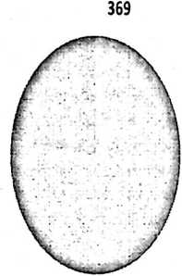
Fig 1: Distribution of Respondents By Sex
■ FEMALE
■ MALE
Figure 1 shows that (78%) of the
respondents are female, while (22%) are
male. This represents the gender distribution
of students involved in the survey.

■ ACCT
■ BUS.ADM
■ ECONS
■ SOCIO
■ ENG
n MASS.COM
■ POL SO
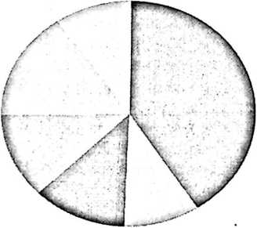

Fig 2: Distribution of Respondents by Department

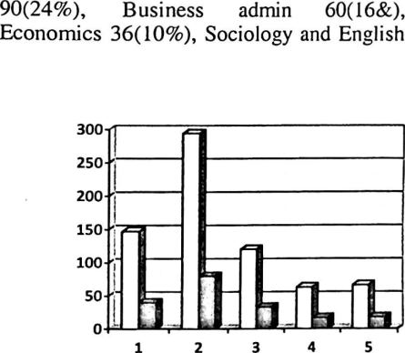
Fig 3: Information Sources
□ FREQUENCY
■ PERCENTAGE
Figure 2 shows that Accounting
department has the highest no of respondents
both 45(12%), Mass communication
57(15%) and Political science 36(10%).

Fig 3: Shows that 40% of the
respondents ask the officer in charge for
information sources,80% of the respondent
browse through the book shelves, 33% make
use of phone and devices to source for information in the library, 17% check
through library instruction course and 18%
browse through the OPAC(online public
access catalogue.).

□ FREQUENCY
9 PERCENTAGE
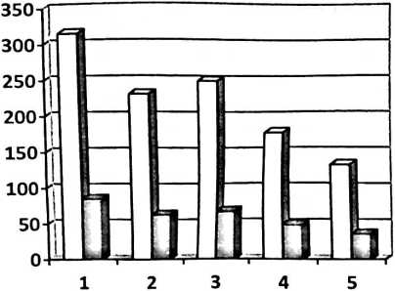

Fig 4: Purpose of use of Information Resources

Figure 4 reveals that 85% of students use
information resources -in the library to
enhance their academic performance.63% to
aid personal development, 67% to do their assignment, 48%read ahead of their lecturers
and 36% to know about current issues.

250
200
150
100
50

□ FREQUENCY
B PERCENTAGE

Fig 5: Barriers to Information Seeking in the Library

Figure 5 shows that 63% of the
respondents indicated non-availability of
current information resources in the library,
34% inaccessibility of information resources
in the library, 26% the library staff are
unfriendly, 26% the internet is not always
available and 19% information materials are
not adequately protected. Thisls in line with
Baro and Fynman (2009) in their study
which pointed out factors such as:
information illiteracy among library users;
absence of computer systems with Internet
connectivity in the university libraries;
poorly conducted user education
programmes etc.as factors that hinder the effective utilization of library resources and
services. This makes it difficult for
undergraduate students to meet their
information needs.

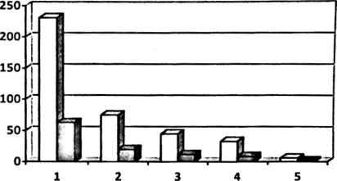
Fig 6: Frequency in the Use of Information Resources in the Library
□ FREQUENCY
B PERCENTAGE
Fig 6, 63% use the library on weekly basis, 20% on daily basis, 12% twice a month, 9%
once in a month 2% never make use of the library
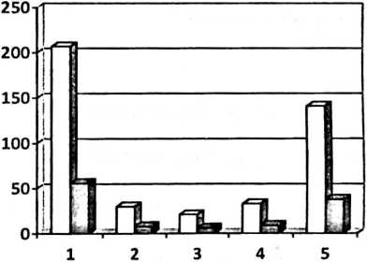
Figure 7, indicate that 56% of the
respondents use Google as the major search
engine when searching for information in the
library. It was found to be the most popularly
used information channel, followed by social
media. These findings correlate with the
findings of Garcia and Silicia (2003) and
Oyewusi and Oyebobe (2009). Google was
found to be the major search engine used by
the university students. 8%' of the
respondents use OPAC (online public access
catalogue), 6% use E-granary, 9% use social
media while 38% use prints materials.
Fig 7: Use Of Search Engines
□ FREQUENCY
■ PERCENTAGE
r
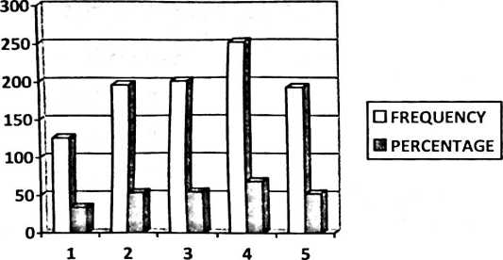

Fig 8: Suggestion of Improving Access to Information Resources in the

Library.

Fig 8 reveals that 34% suggest that
library staff should change their approach to
work,53% suggest that provision should be
make for computer with internet access in
faculties and hall of residence,54% assisting
student to have access to journals and
books,68% library should be stocked with
relevant materials while 52% suggest
creating of awareness programmes for
students.

Conclusion
Conclusively the results from the study show
that undergraduate students of Bingham
University in the faculty of humanities
social and management science(HSMS)
seeks for information in relation to their
academics ,to aid personal development and
to do their assignments . It is quite obvious
that their desire to satisfy their educational
and academic information needs influences
them to seek for information. The
undergraduates from Bingham University,
faculty of H.S.M.S do seek for information
by browsing through the shelves and as well
asking the officer in charge. It was
discovered during the study that a larger
percent of the students browse through the book shelve themselves. The students as
revealed by the study do not go through
available bibliographic sources nor do they
seek for information from the online public
access catalogue (OPAC)
This approach to information
seeking is quite disheartening as most
students out of self confidence has visited
the library and returned without having their
information puzzle dissolved even though
they claimed to be having their information
needs be met through the various approach
they are using.
In the course of the research it was
discovered that a major barrier student face
is non availability of information resources
in the Library.

Recommendations
Certain problems were identified in the
course of this study and here are some
recommendations that will help the
University library to meet information needs
of students adequately.
- Provision of information materials to
meet the information needs of
students.
- Creation of awareness programme
that will enlighten the students in
getting adequate information needed
in the library such as asking a
librarian, the use of Online public
access(OPAC) and E-granary to get
the adequate information they need.
- The internet should be made
accessible always for students to be
able to get the information needed at
the right time.
- The library should acquire relevant
books that will meet the information
needs of users.
- The librarians and the other officers
of the library should be trained
properly for them to be able to meet
the information needs of the students
References
Aina, L.O (2004) Library and Information Science
Text for Africa, Ibadan: Third World
Information Service Limited, pp 60-69.
Ajiboye. J, Telia, A (2007), University Undergraduate
Students’ Information Seeking Behaviour:
Implications for Quality in Higher Education
in Africa. The Turkish Online Journal of
Educational Technology - TO JET, 6
(1).Accessed 20^{,h} April 2016
Akinola, S.F, (2009). Information Seeking Behaviour
of Lecturers in Faculties of Education,
Obafemi Awolowo University, Ile-Ife and
University of Ibadan. Samant Journal of
Information Studies;9(2). Accessed 20th April
2016.
Baro, EE and Fyneman, B. (2009). Information
literacy among undergraduate students in
Niger Delta University. The Electronic
Library, 27 (4): 659-675. Accessed 20^{,h} April
2016.
Fo/orunsho O, Babatope F.E (2012) towards the
satisfaction of information needs of prisoners
In south-west zone -Nigeria: prison libraries
to the rescue in Nigerian Libraries: A journal
of The Nigeria Library Association.45 (2)
94-103.
Laloo, B.Y. (2002).information needs, information
seeking behaviour and users, New Delhi: ESS
Publishers
Nnadozie C.O, Nnadozie C.D (2006) the information
needs of faculty members in a Nigerian
Private University. The Librarian and
information manager: a journal of the
Nigerian Library association Akwa ibom
State chapter.2 (2) pp 127-132.
Nwobasi, R. N., Uwa, E. O.and Ossai-Onah, O.
V.(2013).Information Needs and Seeking
Behaviour of Students in Two Universities in
Imo Slate, Nigeria. Library Philosophy
and Practice (e-joumal).
http://digitalcommons.unl.edu/libphilprac/.
Accessed 20th April 2016.
Oyediran-Tidings, S.O. (2004) Information needs and
seeking behaviour of library users, Result
From Yaba College of Technology, Lagos,
Nigeria Lagos Journal of Library and
Information Science, 2 (2): 77-88. Accessed
20'" April 2016.
Ukpanah M.E (2006) information seeking behaviour
and information needs of law students in
University of Uyo. The Librarian and
information manager: a journal of the
Nigerian Library association Akwa ibom
State chapter. 2(2), 24-30
Wilson, T.D. (2008). Human information behaviour.
Available:
http://inforrn.nu/Articles/vol.3/v3n2.
Accessed 20th April 2016.

